

Software Requirements Specification

for

SHOPPING WEBSITE-Mom and Kid

Version 1.0 approved

Prepared by Team 5

FPT University

27/09/2018

**SIGNATURE PAGE**

**ORIGINATOR:** Phan Anh Tuan – SE05594

**TEAM MEMBER:** Dao Quang Toan – SE05372

Hoang Luong Dung – SE05529

Cao Linh Nhat – SE05871

Pham Viet Hoang – SE06061

**REVIEWERS:** Pham Ngoc Ha

Table of Contents iv

Revision History v

1. Introduction 1

1.1 Purpose 1

1.2 System Purpose 1

1.3 Definitions, Acronyms and Abbreviations 2

1.4 Document Conventions 2

1.5 Intended Audience and Reading Suggestions 2

1.6 Project Scope 2

1.7 References 2

2. Overall Description 3

2.1 Product/System Perspective 3

2.2 System/Product Features 3

2.3 User requirements 4

2.4 User Classes and Characteristics 4

2.5 Operating Environment 4

2.6 Design and Implementation Constraints 5

2.7 User Documentation 5

2.8 Assumptions and Dependencies 5

3. Specific Requirements 6

3.1 Functional Requirements Specification 6

3.1.1 Registration 7

3.1.2 Login 8

3.1.3 Change information 10

3.1.4 Create an order 12

3.1.5 Add/modify a product 14

3.1.6 See information of user 15

3.1.7 Delete a user 16

3.1.8 See information of order 18

3.1.9 Accept/reject an order 20

3.1.10 See report 21

3.2 Non-Functional Requirements Specification 23

3.2.1 External Interface Requirements 23

3.2.2 Other Nonfunctional Requirements 30

4. Other Requirements 32

Appendix A: Database diagram 32

Appendix B: Database entity 33

Revision History

|  |  |  |  |
| --- | --- | --- | --- |
| **Name** | **Date** | **Reason For Changes** | **Version** |
| The whole document | 27/09/2018 | Initiate version for Mom and Kid Website | 1.0 |
|  |  |  |  |

1. Introduction

## Purpose

This document gives information about Shopping system website named Mom and Kid. All functions, information of its, how it be coded, how it works, and all software component will be shown. This document also has a lot of useful for next team developer if another version be developed in the future, support for tester if need fix bug.

## System Purpose

|  |  |
| --- | --- |
| Software | Version |
| Microsoft Windows Server | 2003 SP2 |
| Microsoft SQL Server | 2008 |
| Microsoft .NET Framework | 4.0 |
| Microsoft Visual Studio | 2015 |
| Google Chrome | 69.0.3497.100 |
| Mozilla Firefox | 62.0.2 |
| Opera | 55.0.2994.61 |
| Safari | 12.0 |

## Definitions, Acronyms and Abbreviations

|  |  |  |
| --- | --- | --- |
| ID | Acronyms | Definition |
| 1 | SRS | Software Requirement Specification |
| 2 | DB | Database |
| 3 | GUI | Graphic User Interface |
| 4 | OS | Operating system |
| 5 | M&K | Mom and Kid website |
| 6 | N/A | Not applicable, not available |
| 7 | GB | Gigabyte |

## Document Conventions

This document used Template System Requirement Specification IEEE830 version 1.3. Form-based specifications will be used a lot to describe each of function, input, output, where they come, where they out, information needed, action be taken, pre, post conditions, side effect (if any) of the function.

## Intended Audience and Reading Suggestions

Developer, tester should read document before update coding or fix bugs of previous version.

## Project Scope

Name of this project is Mom and Kid. It is a website for Mom and Kid store that sells products for mother and kid about 1-3 years old. This website focuses on manage importing product, manage selling, manage reporting and manage users.

## References

* Software requirement specification form.
* Software engineering – Ninth Edition (by Ian Sommerville)
* Designing with Web Standards (2nd Edition)
* Model - View - Controller pattern(<https://en.wikipedia.org/wiki/Model–view–controller>)

1. Overall Description

## Product/System Perspective

* Mom and Kid focus on users who:
  + Want to buy product from Mom and Kid shop online
  + Do not have time come to shop and buy product
* On store side, they can:
  + Manage their users: registration, login
  + Manage product in shop: import, sell, …
  + See report: users, product, revenue
  + Manage import product
* Mom and Kid is a website. It run on any operating system has web browser and Internet connection available.

## System/Product Features

* Manage importing product:
  + Add new product
  + Update quantity of product
  + Create report/bill
* Manage shopping:
  + Search a product
  + See detail of product
  + Order
  + Check status of order
  + Accept order
  + Pay
* Create report:
  + Number of products
  + Revenue
  + Number of orders
  + Number of user access
* Manage users:
  + Login
  + Registration
  + Update information

## User requirements

User need a device in any operating system has web browser and Internet connection. Then user must create an account in Mom and Kid website to use full features of website.

Mom and Kid shop will have admin account to use another feature.

## User Classes and Characteristics

Based on analysis, number of babies were born increase year by year. Number of products selling for mom and kid are increasing too. Mom and Kid is a shop which realize that, so they increase limit of selling their products. 2018 is preparation year for 4.0 revolution, they think that a website will help they sell more product instead selling for a limit number of people. They want to sell product for people not only live in near shop, but also from anywhere.

## Operating Environment

* Main programming language: C# with ASP.NET.
* Display: HTML, CSS.
* IDE:
  + Microsoft visual studio 2015
  + .NET framework 3.5
  + Sublime Text version 3.1.1
  + Visual studio code version 1.23
* Database: manage in Microsoft Azure, query use Microsoft SQL Server Management Studio version 17.
* Project workspace, source code: Github.

## Design and Implementation Constraints

* Coding used Model-View-Controller architectural model.
* Variables used camel case (words are joined without spaces and are lowercase with first letter)
* Methods, functions must be commented to support maintenance programmers (comment before functions, before loop, before long code) to understand easily code.
* Code must be coded by convention Java code convention of Oracle.
* Html, Css must be coded by convention Designing with Web Standards (read about they in reference).

## User Documentation

The user documentation will be able as a function of a website, it will use screen captures of website to describe all features.

## Assumptions and Dependencies

Nothing assumptions and dependencies in M&K website version 1.0.

1. Specific Requirements

## Functional Requirements Specification

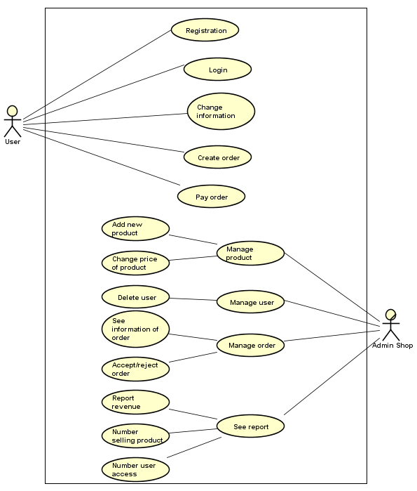

### Registration

|  |  |  |  |
| --- | --- | --- | --- |
| Use Case ID: | MK01 | | |
| **Use Case Name:** | Sign up for user | | |
| **Created By:** | TuanPA | **Last Updated By:** | TuanPA |
| **Date Created:** | Sep 27, 2018 | **Date Last Updated:** | Sep 27, 2018 |
| **Actors:** | User | | |
| **Triggers** | User clicks on registration on the header of website | | |
| **Description:** | Registration for a new user | | |
| **Pre-conditions:** | **MK01_PRE_1**. User is in website M&K | | |
| **Post-conditions:** | Full name, password, email, phone number, address will be added to database | | |
| **Normal Flow:** | MK01_NF_1. User clicks on registration in the header of M&K website  MK01_NF_2. Website display form registration: full name, email, password, re-password, phone, submit button  **MK01_NF_3.** User fills up, clicks on submit button  **MK01_NF_4.** Website validates email, passwords and show “Registration successful” | | |
| **Alternative Flows:** | **MK01_AT_1.** At step MK01_NF_4, if email is existed in database, show error “email if existed, enter another email”  **MK01_AT_2.** At step MK01_NF_3, if re-password is different password, ask user enter re-password again | | |
| **Exceptions:** | N/A | | |
| **Priority:** | Normal | | |
| **Other information:** | Email must be valid email  Password is greater or equal 8 character  User can discard value entered by click [Cancel] button and [Back] instead of [OK] button. | | |
| **Frequency of Use:** | Usually | | |
| **Business Rules:** | N/A | | |
| **Assumptions:** | N/A | | |

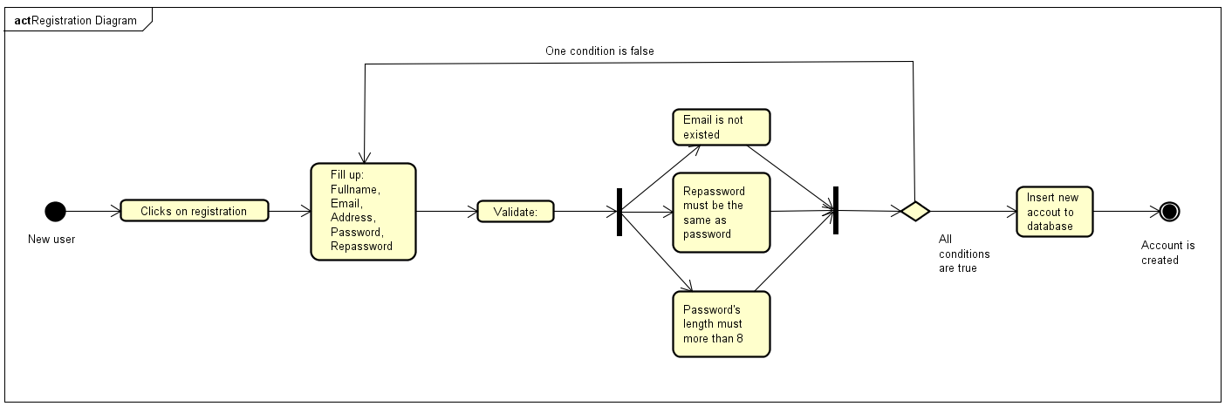

### Login

|  |  |  |  |
| --- | --- | --- | --- |
| Use Case ID: | MK02 | | |
| **Use Case Name:** | Login for user | | |
| **Created By:** | TuanPA | **Last Updated By:** | TuanPA |
| **Date Created:** | Sep 27, 2018 | **Date Last Updated:** | Sep 27, 2018 |
| **Actors:** | User | | |
| **Triggers** | User clicks on Login on the header of website | | |
| **Description:** | Registration for a new user | | |
| **Pre-conditions:** | **MK02_PRE_1**. User is in website M&K | | |
| **Post-conditions:** | A connection to database is initialized. Update number of people access in database | | |
| **Normal Flow:** | MK02_NF_1. User clicks on login in the header of M&K website  MK02_NF_2. Website display form registration: email, password, submit button  **MK02_NF_3.** User fills up, clicks on submit button  **MK02_NF_4.** Website validates username, email, passwords and show “Login successful”  **MK02_NF_5.** If user forgot password, click Forget password and fill up mail. | | |
| **Alternative Flows:** | **MK02_AF_1.** At step MK02_NF_4, if username is existed but password is not correct in database, show error: “Login information is not invalid”  **MK02_AF_2.** At step MK02_NF_4, if username is not found in database, show error: “Login information is not invalid” | | |
| **Exceptions:** | N/A | | |
| **Priority:** | Normal | | |
| **Other information:** | N/A | | |
| **Frequency of Use:** | Usually | | |
| **Business Rules:** | N/A | | |
| **Assumptions:** | N/A | | |

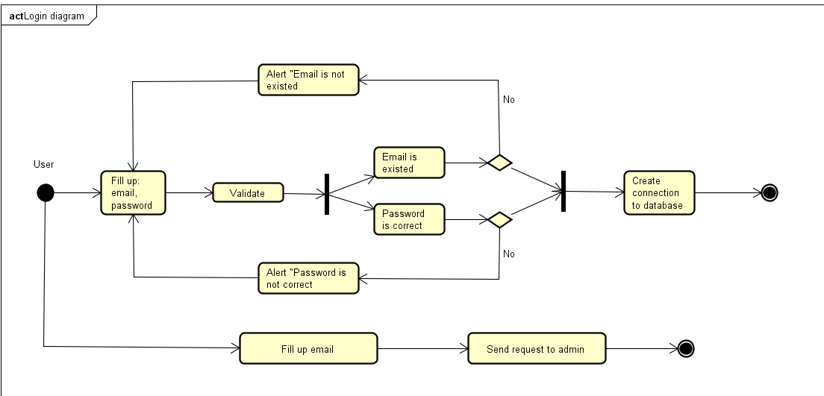

### Change information

|  |  |  |  |
| --- | --- | --- | --- |
| Use Case ID: | MK03 | | |
| **Use Case Name:** | Change information for user | | |
| **Created By:** | TuanPA | **Last Updated By:** | TuanPA |
| **Date Created:** | Sep 27, 2018 | **Date Last Updated:** | Sep 27, 2018 |
| **Actors:** | User | | |
| **Triggers** | User clicks on change information after click on their icon on the header of website | | |
| **Description:** | User changes information: password, phone number, address. | | |
| **Pre-conditions:** | **MK03_PRE_1**. User is login website M&K  **MK03_PRE_2.** User clicks on their avatar in header of website  **MK03_PRE_3.** User clicks on change information | | |
| **Post-conditions:** | Information of user may be changed and update again to database | | |
| **Normal Flow:** | MK03_NF_1. User fills up text box password and re-password if want to change password  MK03_NF_2. User fills up text box email if want to change password  **MK03_NF_3.** User fills up text box phone number if want to change password  **MK03_NF_4.** User fills up text box address if want to change password  **MK03_NF_4.** User click submit button | | |
| **Alternative Flows:** | **MK03_AF_1.** At step MK02_NF_1, if password is not the same as re-password, alert to user: “Re-password must be the same as password”, user cannot submit request change information  **MK03_AF_1.** At step MK02_NF1_1, if password is not strong enough, alert to user: “Password is weak”, user cannot submit request change information | | |
| **Exceptions:** | N/A | | |
| **Priority:** | Normal | | |
| **Other information:** | Email must be valid email  Password is greater or equal 8 character  User can discard value entered by click [Cancel] button and [Back] instead of [OK] button. | | |
| **Frequency of Use:** | Usually | | |
| **Business Rules:** | N/A | | |
| **Assumptions:** | N/A | | |

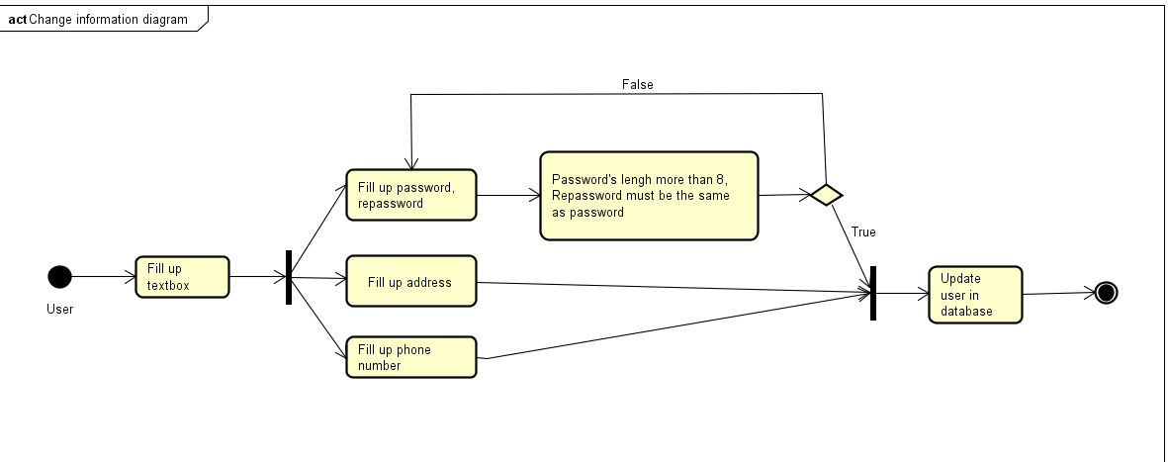

### Create an order

|  |  |  |  |
| --- | --- | --- | --- |
| Use Case ID: | MK04 | | |
| **Use Case Name:** | Create an order | | |
| **Created By:** | TuanPA | **Last Updated By:** | TuanPA |
| **Date Created:** | Sep 27, 2018 | **Date Last Updated:** | Sep 27, 2018 |
| **Actors:** | User | | |
| **Triggers** | User clicks on pay a product, click on cart and click on pay cart | | |
| **Description:** | User add a product to cart | | |
| **Pre-conditions:** | **MK04_PRE_1**. User is login website M&K  **MK04_PRE_2.** User clicks on product their want to buy  **MK04_PRE_3.** User clicks on add to cart | | |
| **Post-conditions:** | A cart with product is create and add to database, a request pay cart send to admin | | |
| **Normal Flow:** | MK04_NF_1. User changes quantity of a product in box cart display.  MK04_NF_2. User click on “x” if want to discard this product.  MK04_NF_3. User click on update cart to update new price  **MK04_NF_4.** User click on Continue shopping if want to buy more  **MK04_NF_5.** User click on Pay if want to pay now  **MK04_NF_6**. User clicks on pay, message alert: “Successful. Our shop will contact you soon” | | |
| **Alternative Flows:** | **MK04_AF_1.** At step MK04_NF_1, quantity must be a number greater than 0  **MK04_AF_2**. Before step MK04_NF_6, must be at least 1 product | | |
| **Exceptions:** | N/A | | |
| **Priority:** | Normal | | |
| **Other information:** | N/A  User can discard value entered by click [Cancel] button and [Back] instead of [OK] button. | | |
| **Frequency of Use:** | Usually | | |
| **Business Rules:** | N/A | | |
| **Assumptions:** | N/A | | |



### Add/modify a product

|  |  |  |  |
| --- | --- | --- | --- |
| Use Case ID: | MK06 | | |
| **Use Case Name:** | Add products for admin | | |
| **Created By:** | TuanPA | **Last Updated By:** | TuanPA |
| **Date Created:** | Sep 27, 2018 | **Date Last Updated:** | Sep 27, 2018 |
| **Actors:** | Admin | | |
| **Triggers** | Admin click on add new product on menu | | |
| **Description:** | Product will be added to database | | |
| **Pre-conditions:** | **MK06_PRE_1**. Admin is login website M&K by admin account  **MK06_PRE_2**. Admin is click on manage product on menu  **MK06_PRE_3.** Admin click on add new product on submenu | | |
| **Post-conditions:** | Quantity’s old product/new product with will be updated | | |
| **Normal Flow:** | MK06_NF_1. Admin fills up: id, name, price and quantity.  MK06_NF_2. Admin clicks on submit, message alert: “Successful” | | |
| **Alternative Flows:** | **MK06_AF_1.** At step MK07_NF_1, if id is not existed, alert: “This product is not existed” | | |
| **Exceptions:** | N/A | | |
| **Priority:** | Normal | | |
| **Other information:** | All text box must be filled up if create new product Only id must be filled up if modify | | |
| **Frequency of Use:** | Usually | | |
| **Business Rules:** | If admin modified quantity of old product, it means that quantity will be add to old quantity of that product | | |
| **Assumptions:** | N/A | | |

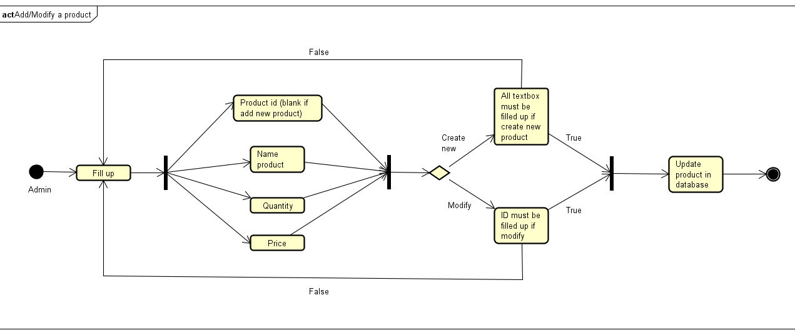

### See information of user

|  |  |  |  |
| --- | --- | --- | --- |
| Use Case ID: | MK08 | | |
| **Use Case Name:** | See information of all users | | |
| **Created By:** | TuanPA | **Last Updated By:** | TuanPA |
| **Date Created:** | Sep 27, 2018 | **Date Last Updated:** | Sep 27, 2018 |
| **Actors:** | Admin | | |
| **Triggers** | Admin click on manage user on menu | | |
| **Description:** | Price’s product will be updated to database | | |
| **Pre-conditions:** | **MK08_PRE_1**. Admin is login website M&K by admin account  **MK08_PRE_2**. Admin is click on manage user on menu | | |
| **Post-conditions:** | List of users is shown. | | |
| **Normal Flow:** | MK08_NF_1. Admin clicks on manage user | | |
| **Alternative Flows:** | N/A | | |
| **Exceptions:** | N/A | | |
| **Priority:** | Normal | | |
| **Other information:** | N/A | | |
| **Frequency of Use:** | Usually | | |
| **Business Rules:** | N/A | | |
| **Assumptions:** | N/A | | |

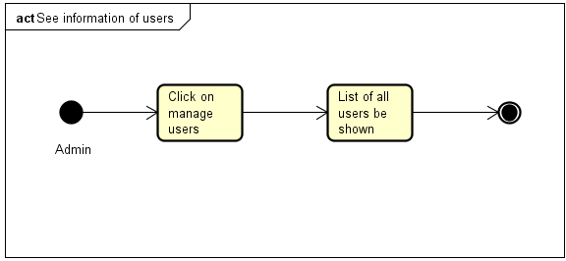

### Delete a user

|  |  |  |  |
| --- | --- | --- | --- |
| Use Case ID: | MK09 | | |
| **Use Case Name:** | Delete a user | | |
| **Created By:** | TuanPA | **Last Updated By:** | TuanPA |
| **Date Created:** | Sep 27, 2018 | **Date Last Updated:** | Sep 27, 2018 |
| **Actors:** | Admin | | |
| **Triggers** | Admin click on manage user on menu | | |
| **Description:** | Price’s product will be updated to database | | |
| **Pre-conditions:** | **MK09_PRE_1**. Admin is login website M&K by admin account  **MK09_PRE_2**. Admin is click on manage user on menu | | |
| **Post-conditions:** | User may be deleted in database | | |
| **Normal Flow:** | MK09_NF_1. Admin clicks on delete button on the side of user table  MK09_NF_2. Admin clicks on yes/no on confirm dialog | | |
| **Alternative Flows:** | N/A | | |
| **Exceptions:** | N/A | | |
| **Priority:** | Normal | | |
| **Other information:** | N/A | | |
| **Frequency of Use:** | Usually | | |
| **Business Rules:** | N/A | | |
| **Assumptions:** | N/A | | |

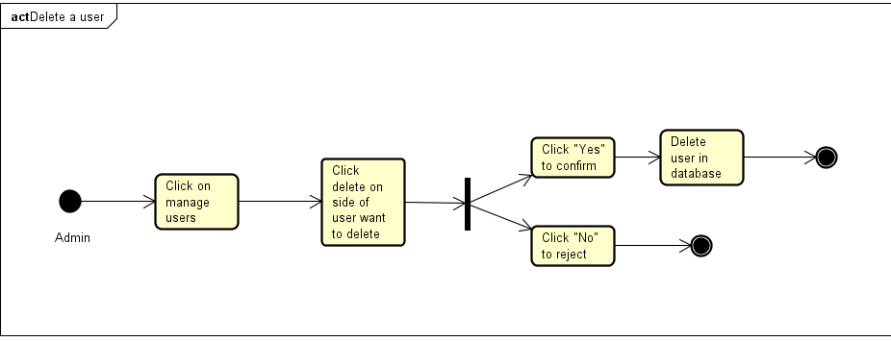

### See information of order

|  |  |  |  |
| --- | --- | --- | --- |
| Use Case ID: | MK10 | | |
| **Use Case Name:** | See information of order | | |
| **Created By:** | TuanPA | **Last Updated By:** | TuanPA |
| **Date Created:** | Sep 27, 2018 | **Date Last Updated:** | Sep 27, 2018 |
| **Actors:** | Admin | | |
| **Triggers** | Admin click on manage order on menu | | |
| **Description:** | All order will be shown | | |
| **Pre-conditions:** | **MK10_PRE_1**. Admin is login website M&K by admin account  **MK10_PRE_2**. Admin is click on manage order on menu | | |
| **Post-conditions:** | N/A | | |
| **Normal Flow:** | MK10_NF_1. Admin is click on manage order on menu  **MK10_NF_2**. Admin is click on an order in list | | |
| **Alternative Flows:** | N/A | | |
| **Exceptions:** | N/A | | |
| **Priority:** | Normal | | |
| **Other information:** | N/A | | |
| **Frequency of Use:** | Usually | | |
| **Business Rules:** | N/A | | |
| **Assumptions:** | N/A | | |

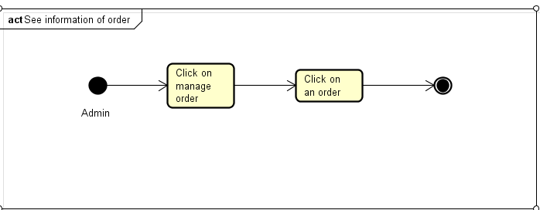

### Accept/reject an order

|  |  |  |  |
| --- | --- | --- | --- |
| Use Case ID: | MK11 | | |
| **Use Case Name:** | Accept/reject an order | | |
| **Created By:** | TuanPA | **Last Updated By:** | TuanPA |
| **Date Created:** | Sep 27, 2018 | **Date Last Updated:** | Sep 27, 2018 |
| **Actors:** | Admin | | |
| **Triggers** | Admin click on manage order on menu | | |
| **Description:** | User’s order may be accepted/rejected | | |
| **Pre-conditions:** | **MK11_PRE_1**. Admin is login website M&K by admin account  **MK11_PRE_2**. Admin is click on manage order on menu | | |
| **Post-conditions:** | Status of order will be updated in database | | |
| **Normal Flow:** | MK11_NF_1. Admin is click on manage order on menu  **MK11_NF_2**. Admin is click on an order in list  **MK11_NF_3**. Admin is click on accept/reject button | | |
| **Alternative Flows:** | N/A | | |
| **Exceptions:** | N/A | | |
| **Priority:** | Normal | | |
| **Other information:** | N/A | | |
| **Frequency of Use:** | Usually | | |
| **Business Rules:** | N/A | | |
| **Assumptions:** | N/A | | |

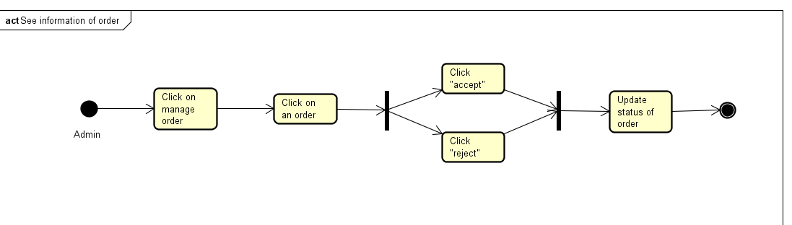

### See report

|  |  |  |  |
| --- | --- | --- | --- |
| Use Case ID: | MK12 | | |
| **Use Case Name:** | See report revenue | | |
| **Created By:** | TuanPA | **Last Updated By:** | TuanPA |
| **Date Created:** | Sep 27, 2018 | **Date Last Updated:** | Sep 27, 2018 |
| **Actors:** | Admin | | |
| **Triggers** | Admin click on manage report on menu | | |
| **Description:** | User’s order may be accepted/rejected | | |
| **Pre-conditions:** | **MK12_PRE_1**. Admin is login website M&K by admin account | | |
| **Post-conditions:** | Revenue report, number selling product report, number user access report will be shown by chart though each month. | | |
| **Normal Flow:** | N/A | | |
| **Alternative Flows:** | N/A | | |
| **Exceptions:** | N/A | | |
| **Priority:** | Normal | | |
| **Other information:** | N/A | | |
| **Frequency of Use:** | Usually | | |
| **Business Rules:** | N/A | | |
| **Assumptions:** | N/A | | |

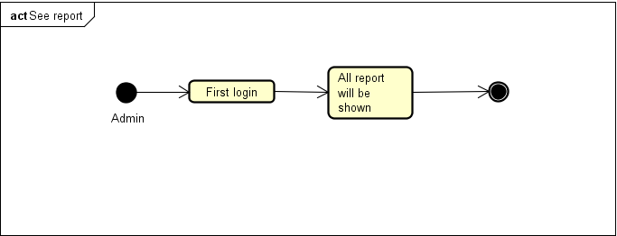

## Non-Functional Requirements Specification

### External Interface Requirements

#### User Interfaces

Screen 1: user accesses M&K website

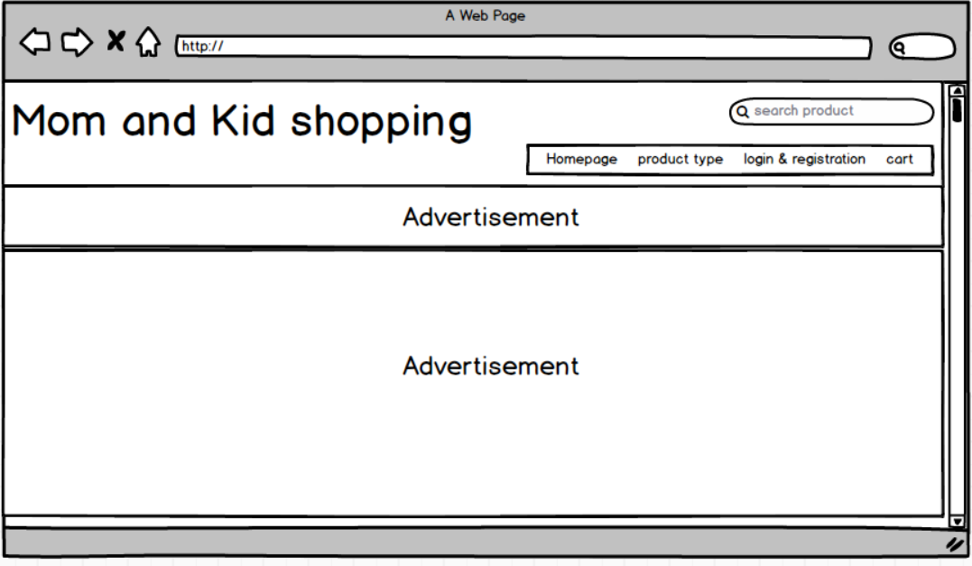

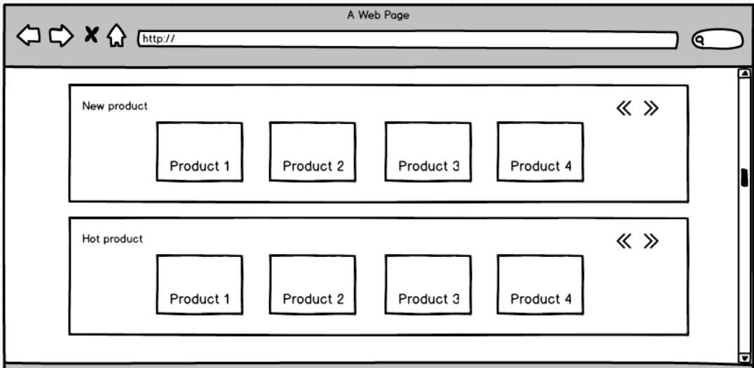

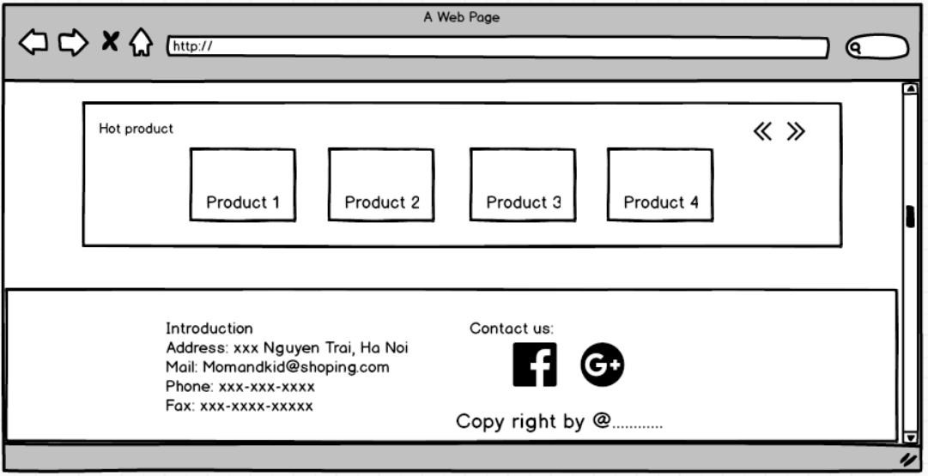

Screen 2: user clicks on product type

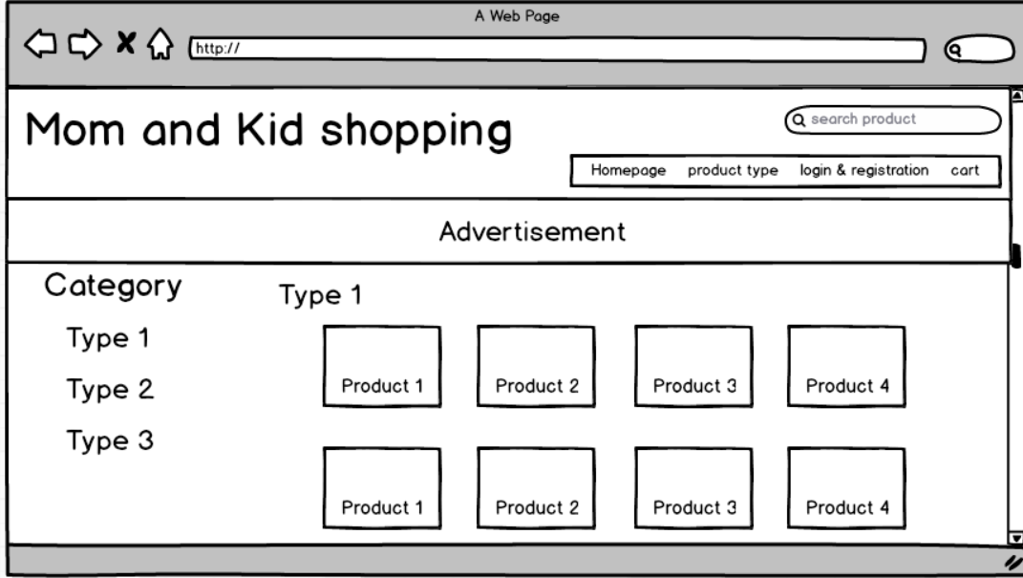

Screen 3: user clicks on login & registration

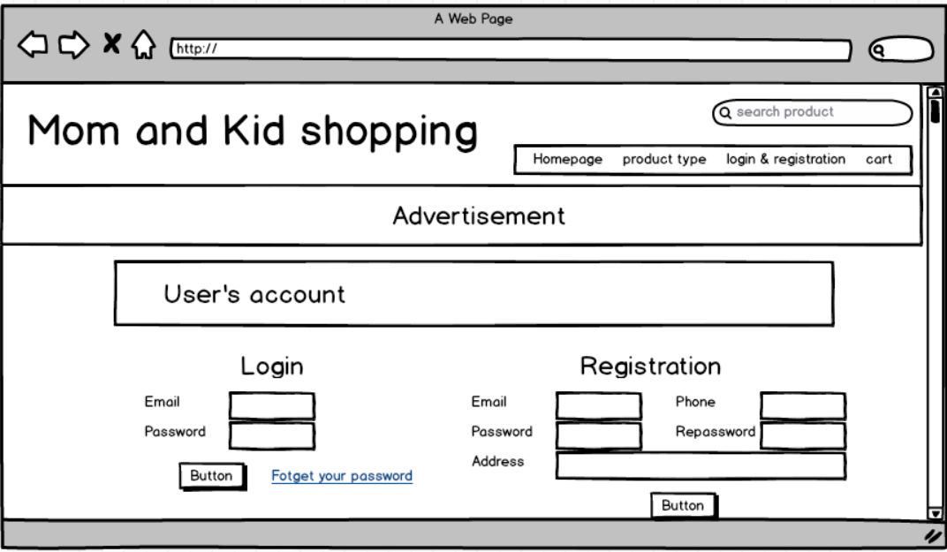

Screen 4: user clicks on a product

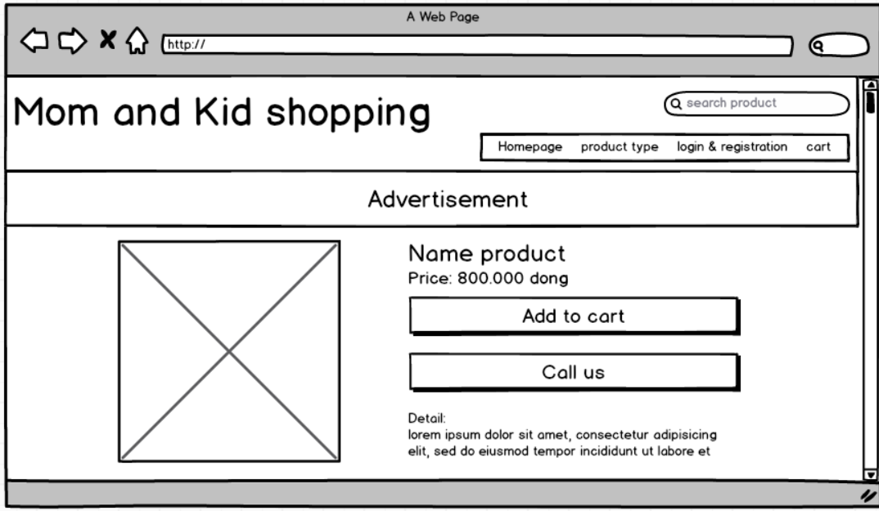

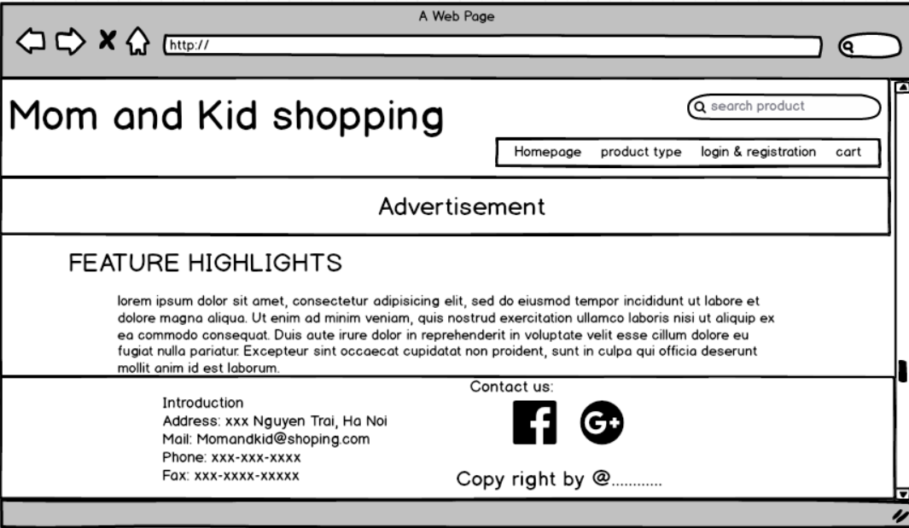

Screen 5: user clicks on cart

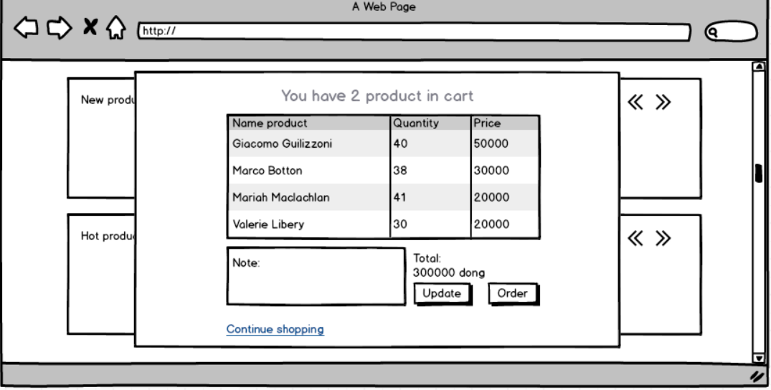

Screen 4: user first login

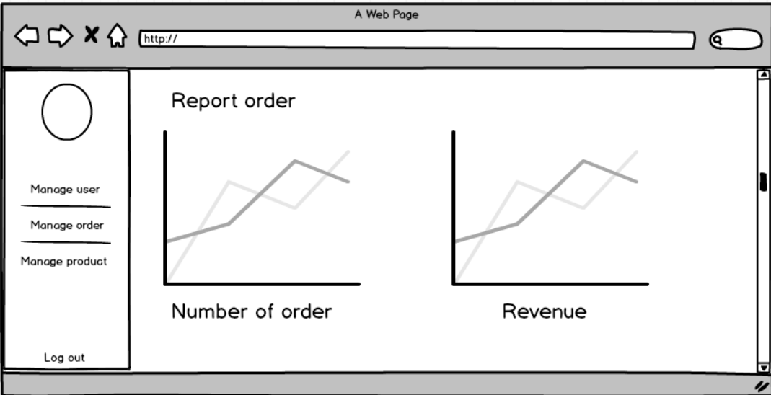

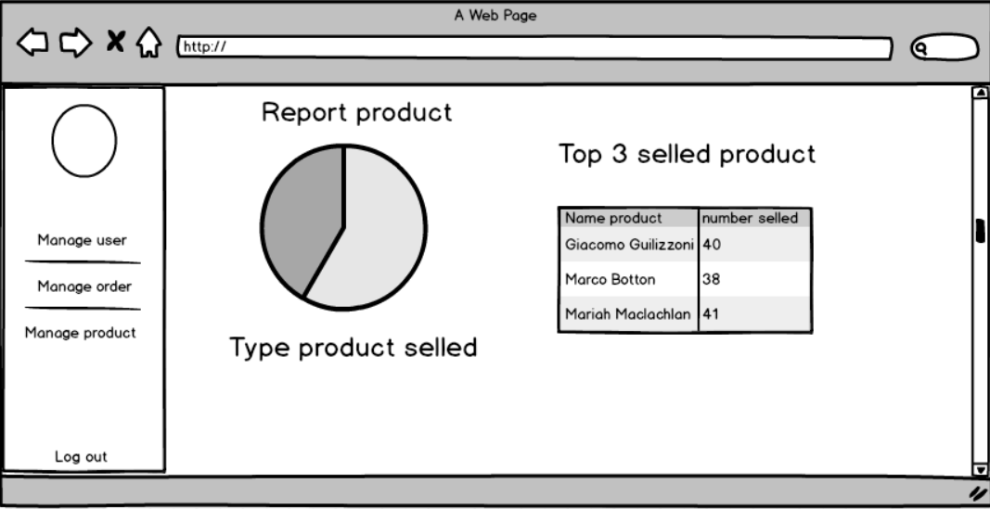

Screen 5: admin clicks on manage user

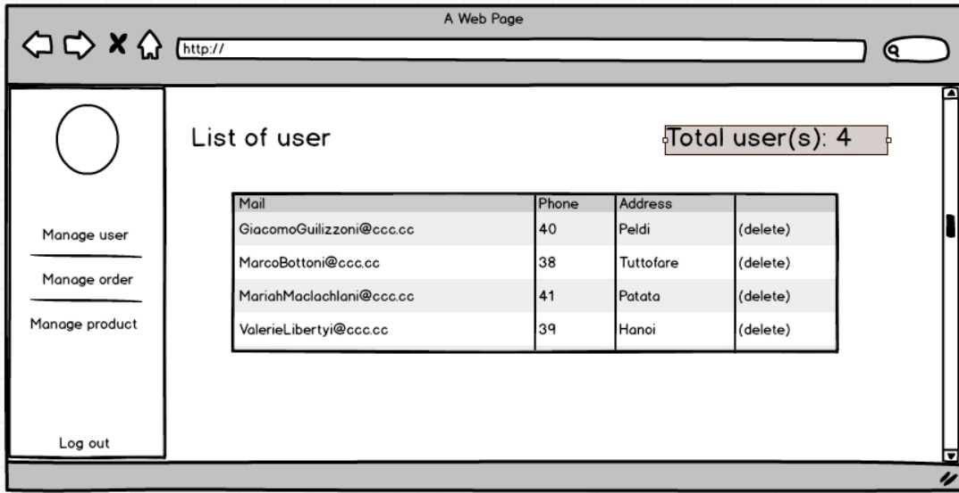

Screen 6: admin clicks on manage order

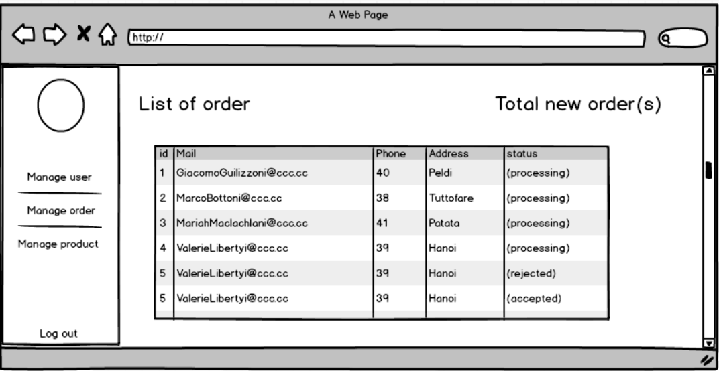

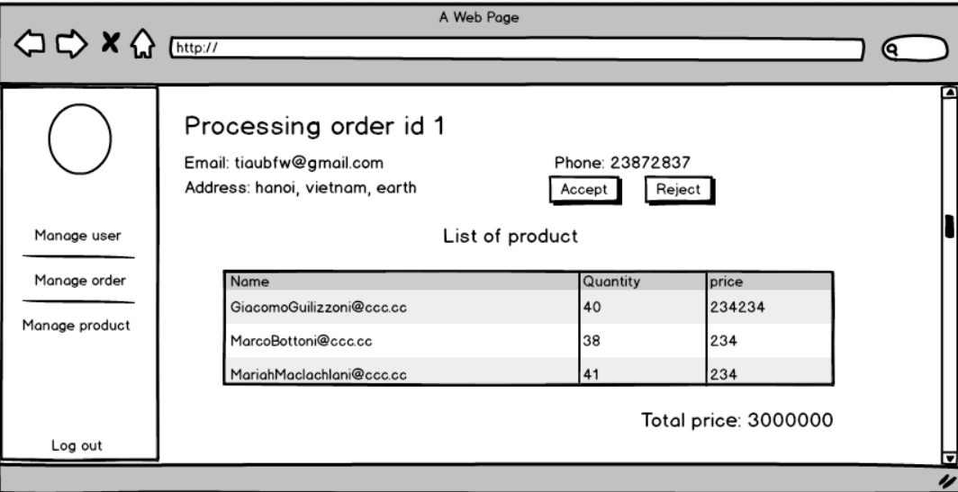

Screen 7: Admin clicks on manage product

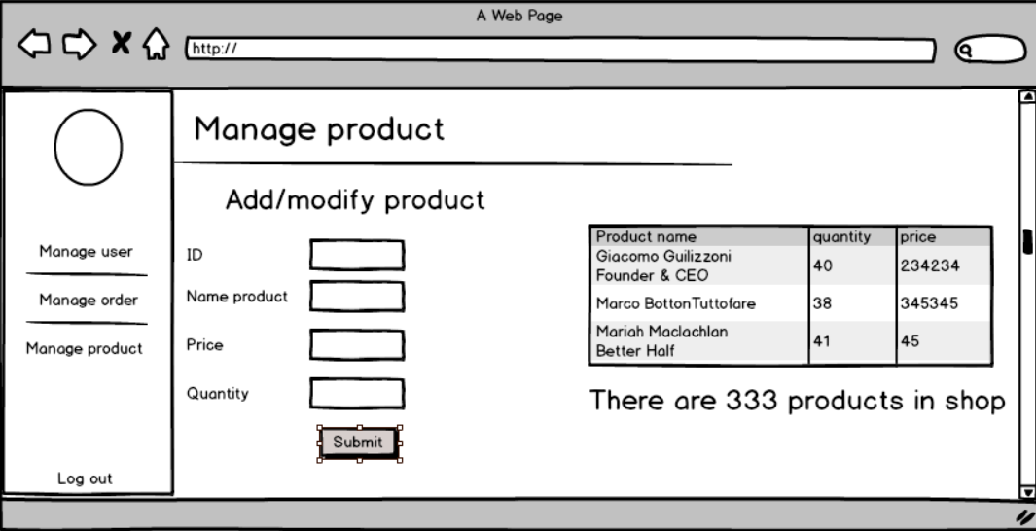

#### Hardware Interfaces

It strongly recommended that user use a desktop device instead of mobile device because some feature may be not work well in mobile in version 1.0 of M&K website. Don’t forget that you must have an internet connection like Wan – Lan.

Recommend that user should use new version of Chrome, Firefox, Safari, Edge. Internet Explorer may be not fully supported this website.

#### Software Interfaces

As it has already been started, M&K run on almost browser with internet on any OS on client side. With server side, all most functions depend on database. See information of database in Appendix.

#### Communications Interfaces

M&K use HTTP for communication over the internet.

### Other Nonfunctional Requirements

#### Performance Requirements

First version 1.0 of M&K website does not require powerful processor, more ram or need card graphic. It will run fast all most feature. But this version just used connection database with 5 database transaction units and 2GB memory from Azure DB. if there are over 500 connections to website, connection to database may be slowly. Speed and bandwidth of connection database should be upgrade in next version.

#### Design constraints

Coding design constraints uses Model-View-Controller pattern.

#### Safety Requirements

If developers are not careful, data in database can be loss. You must remember to save backup data to rollback if something wrong happened. M&K website version 1.0 doesn’t have more feature for admin because if admin lost account administrator, it’s very difficult to rollback data when database is deleted.

#### Security Requirements

Admin never sees another account password. System back-end servers is only accessible by administrator, all database is encrypted.

First version 1.0 is also initialization version so DDOS server may be happened. Delay time access will apply if DDOS happen to decrease number of DDOS happens in the future. Next version must improve plan to defense out of DDOS.

#### Software Quality Attributes

M&K website has quite easy GUI with all features can be access from homepage. User can easy accesses to a feature from header of website. All feedback can be sent to email on the footer of website.

1. Other Requirements

Appendix A: Database diagram

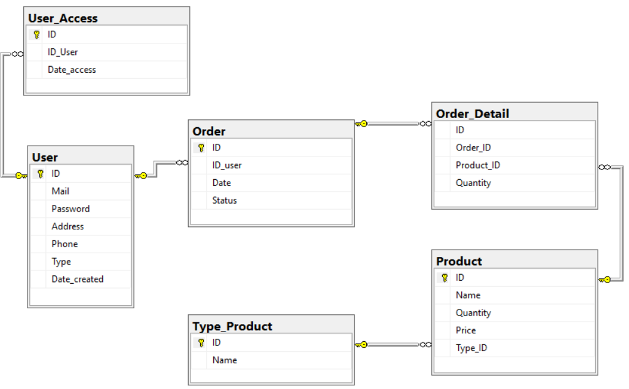

Appendix B: Database entity

1. User

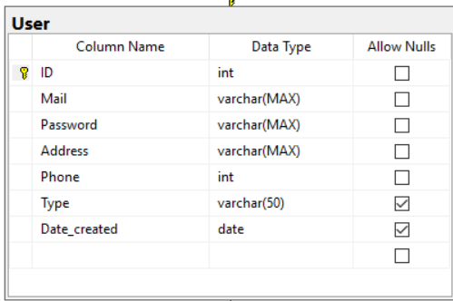

* Save information of user
* Include fields: ID, Mail, Password, Address, Phone, Type, Date_created
* Password will be saved by Hash function

1. User_access

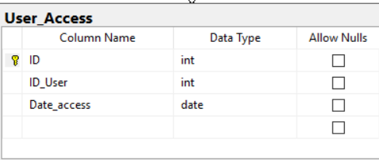

* Save record access of user
* Include fields: ID, ID_User, Date_access

1. Order

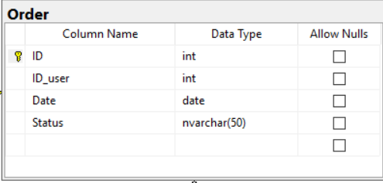

* Save record for a request order from user
* Include fields: ID, ID_user, Date, Status.

1. Order_detail

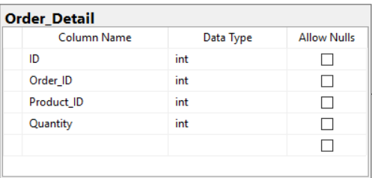

* Save detail of an order
* Include fields: ID, Order_ID, Product_ID, Quantity.

1. Product

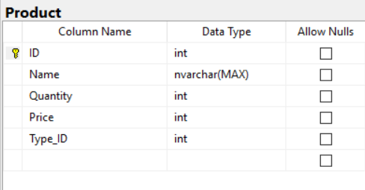

* Save information of a product
* Include fields: ID, Name, Quantity, Price, Type_ID

1. Type_Product

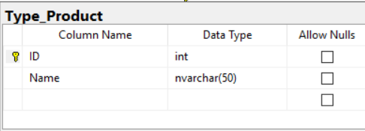

* Save information of type all product
* Include fields: ID, Name